*Core Java - Collections Assignment*

**Instructions:**

Below you will find a series of assignments that you will complete in this exercise. You will need to create a new project folder for this task and name it **Java_Assignment_10_Collections**. You can use the default settings when creating the new project.

For each of the below assignments you will create new classes as specified below. You can keep them in the default package.

Most classes will NOT declare a main() method except for the Application.java file that you will write for a package. In your assignments, you will execute the main() method of the Application.java file.

**Assignments**

1. Write a class **Account** that declares an id (long) property and an accountType (String) property. Create a method that has the following signature:

List<Account> createAccounts(int numAccounts).

The method should create a number of Accounts equal to the numAccounts parameter and return those accounts in a List. For example, createAccounts(5) should create five instances of Account and return those in a List.

In an Application class, call the createAccounts() and then loop through the returned List and print the ids of each Account.

**Goal:**

The purpose of this assignment is to provide you practice with writing classes that make use of Collections. You will utilize the **main()** method of your classes to execute a particular goal of the assignment. This main() method should be implemented in a Application.java file.

By the end of this assignment, you will have 1 new project folder with the classes that meet the requirements mentioned above.

**Helpful Notes**

Project Structure:

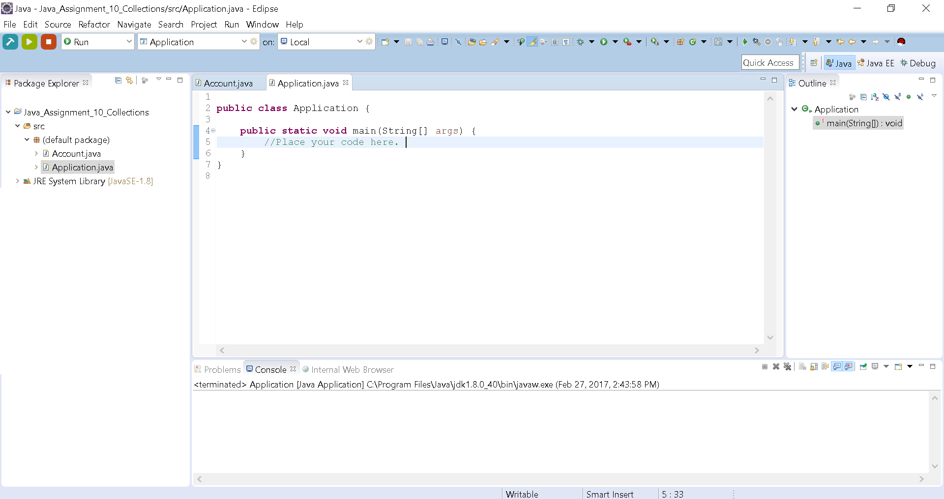

* Your project structure should resemble the above. Note that the name of the project is **Java_Assignment_10_Collections** and all class files are named according to the associated assigned number

Assignment Classes:

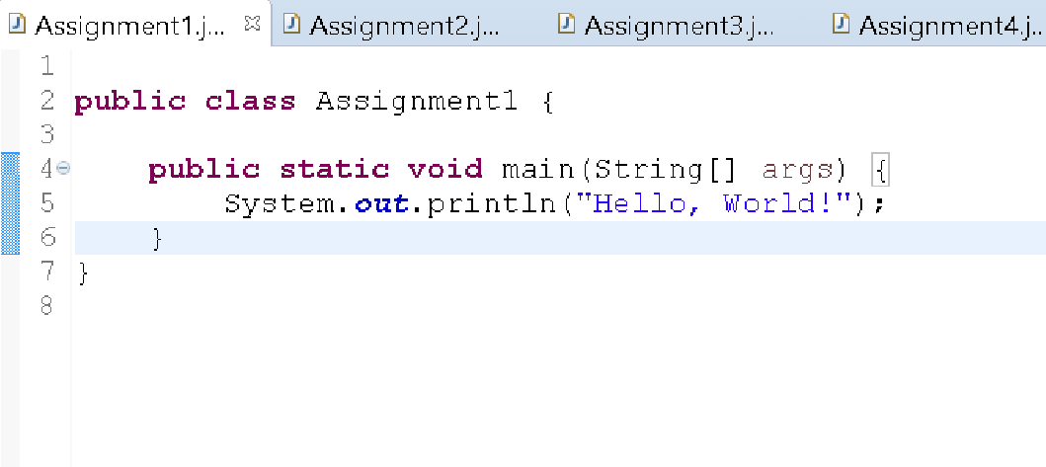

* Notice the indentation of the statement on line 5 to show that it is part of the main() method. Likewise, your code should follow this pattern.